

Lab - Calculate IPv4 Subnets

Objectives

Part 1: Determine IPv4 Address Subnetting

Part 2: Calculate IPv4 Address Subnetting

Background / Scenario

The ability to work with IPv4 subnets and determine network and host information based on a given IP address and subnet mask is critical to understanding how IPv4 networks operate. The first part is designed to reinforce how to compute network IP address information from a given IP address and subnet mask. When given an IP address and subnet mask, you will be able to determine other information about the subnet.

- 1 PC (Windows with Internet access)

- Optional: IPv4 address calculator

Instructions

Fill out the tables below with appropriate answers given the IPv4 address, original subnet mask, and new subnet mask.

Problem 1:

 | Given:
Host IP Address: |  | 192.168.200.139
Original Subnet Mask |  | 255.255.255.0
New Subnet Mask: |  | 255.255.255.224
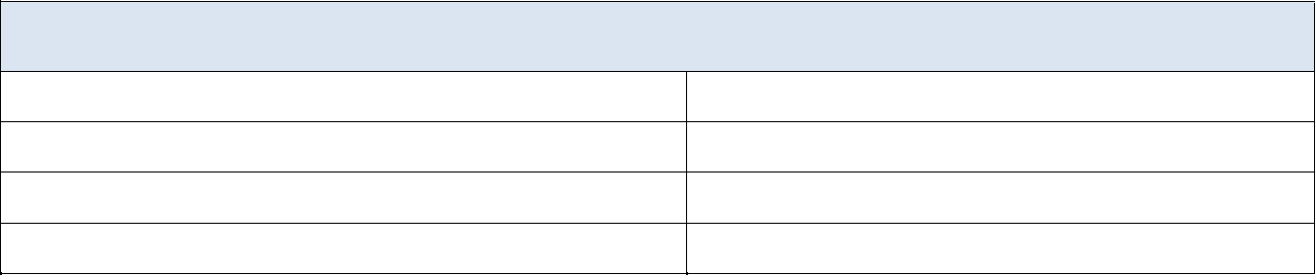

Find:

Number of Subnet Bits
blank

Number of Subnets Created
blank

Number of Host Bits per Subnet
blank

Number of Hosts per Subnet
blank

Network Address of this Subnet
blank

IPv4 Address of First Host on this Subnet
blank

IPv4 Address of Last Host on this Subnet
blank

IPv4 Broadcast Address on this Subnet
blank

© 2013 - 2019 Cisco and/or its affiliates. All rights reserved. Cisco Public Page 1 of 4 www.netacad.com
Lab - Calculate IPv4 Subnets

Problem 2:

 | Given:
Host IP Address: |  | 10.101.99.228
Original Subnet Mask |  | 255.0.0.0
New Subnet Mask: |  | 255.255.128.0
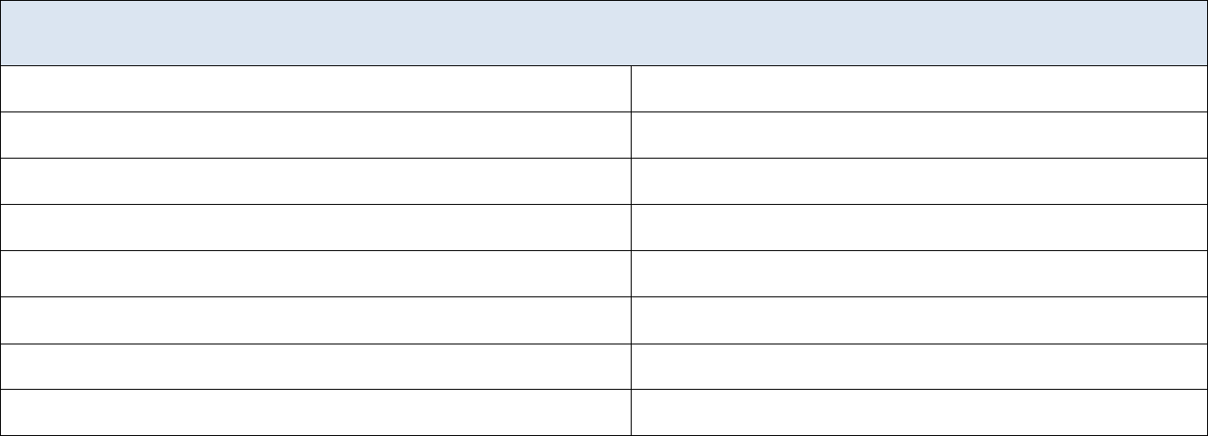

Find:

Number of Subnet Bits
blank

Number of Subnets Created
blank

Number of Host Bits per Subnet
blank

Number of Hosts per Subnet
blank

Network Address of this Subnet
blank

IPv4 Address of First Host on this Subnet
blank

IPv4 Address of Last Host on this Subnet
blank

IPv4 Broadcast Address on this Subnet
blank

Problem 3:

 | Given:
Host IP Address: |  | 172.22.32.12
Original Subnet Mask |  | 255.255.0.0
New Subnet Mask: |  | 255.255.224.0
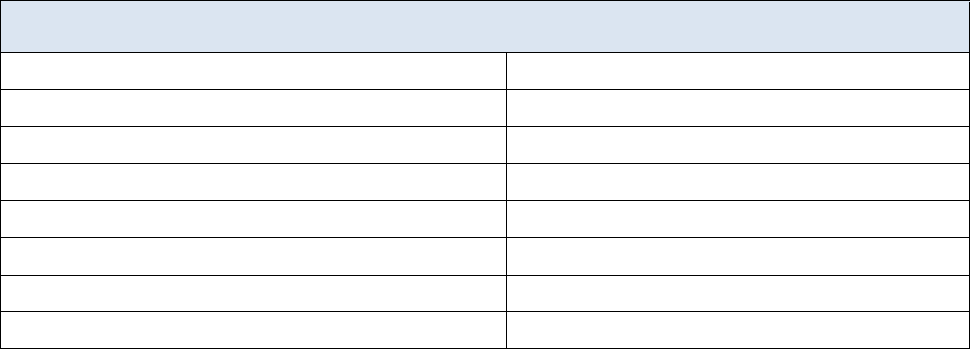

Find:

Number of Subnet Bits
blank

Number of Subnets Created
blank

Number of Host Bits per Subnet
blank

Number of Hosts per Subnet
blank

Network Address of this Subnet
blank

IPv4 Address of First Host on this Subnet
blank

IPv4 Address of Last Host on this Subnet
blank

IPv4 Broadcast Address on this Subnet
blank

© 2013 - 2019 Cisco and/or its affiliates. All rights reserved. Cisco Public Page 2 of 4 www.netacad.com

Lab - Calculate IPv4 Subnets

Problem 4:

 | Given:
Host IP Address: |  | 192.168.1.245
Original Subnet Mask |  | 255.255.255.0
New Subnet Mask: |  | 255.255.255.252
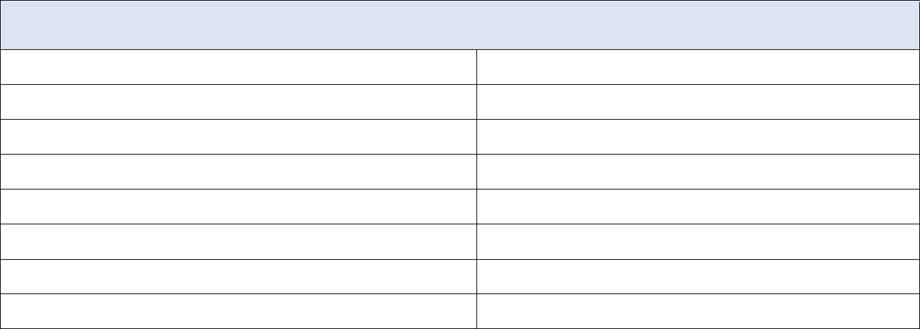

Find:

Number of Subnet Bits
blank

Number of Subnets Created
blank

Number of Host Bits per Subnet
blank

Number of Hosts per Subnet
blank

Network Address of this Subnet
blank

IPv4 Address of First Host on this Subnet
blank

IPv4 Address of Last Host on this Subnet
blank

IPv4 Broadcast Address on this Subnet
blank

Problem 5:

 | Given:
Host IP Address: |  | 128.107.0.55
Original Subnet Mask |  | 255.255.0.0
New Subnet Mask: |  | 255.255.255.0

Find:

Number of Subnet Bits
blank

Number of Subnets Created
blank

Number of Host Bits per Subnet
blank

Number of Hosts per Subnet
blank

Network Address of this Subnet
blank

IPv4 Address of First Host on this Subnet
blank

IPv4 Address of Last Host on this Subnet
blank

IPv4 Broadcast Address on this Subnet
blank

© 2013 - 2019 Cisco and/or its affiliates. All rights reserved. Cisco Public Page 3 of 4 www.netacad.com

Lab - Calculate IPv4 Subnets

Problem 6:

 | Given:
Host IP Address: |  | 192.135.250.180
Original Subnet Mask |  | 255.255.255.0
New Subnet Mask: |  | 255.255.255.248

Find:

Number of Subnet Bits
blank

Number of Subnets Created
blank

Number of Host Bits per Subnet
blank

Number of Hosts per Subnet
blank

Network Address of this Subnet
blank

IPv4 Address of First Host on this Subnet
blank

IPv4 Address of Last Host on this Subnet
blank

IPv4 Broadcast Address on this Subnet
blank

Reflection Question

Why is the subnet mask so important when analyzing an IPv4 address?

Type your answers here.

End of Document

End of document

© 2013 - 2019 Cisco and/or its affiliates. All rights reserved. Cisco Public Page 4 of 4 www.netacad.com

